Building Code
Summary: A building code is a set of rules that establishes the minimum standards for the development and use of an AI system.
Type of pattern: Governance pattern
Type of objective: Trustworthiness
Target users: RAI governors
Impacted stakeholders: AI technology producers and procurers, AI solution producers and procurers, RAI tool producers and procurers
Lifecycle stages: All stages
Relevant AI ethics principles: Human, societal and environmental wellbeing, human-centered values, fairness, privacy protection and security, reliability and safety, transparency and explainability, contestability, accountability
Mapping to AI regulations/standards: EU AI Act, ISO/IEC 42001:2023 Standard.
Context: AI systems can be more uncertain and riskier than traditional software due to their autonomous and opaque decision-making processes. The level of uncertainty and risk may vary depending on the specific AI technologies and application domains being used. As AI technology continues to evolve and become more prevalent, there is a need for clear and consistent guidelines for developers to follow to ensure that AI systems are developed and used responsibly.
Problem: What are ways to ensure that AI systems are trustworthy and meet certain minimum responsible AI standards?
Solution: A building code is a set of rules that ensures the development and use of AI systems conform to certain minimum standards [1]. Building codes are usually developed by standards organizations or governments and may be formally enacted as law in a particular jurisdiction. Developers must comply with building codes to obtain developmental approval or liability insurance for their AI systems.
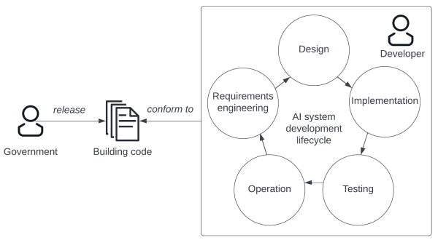
Fig.1. Building code.

Benefits:
- Reduced RAI risk: Building codes can help to reduce the RAI issues in the development and use of AI systems.
- Concrete guidance: Building codes provide concrete guidelines for companies on how to develop a trustworthy AI system.
Drawbacks:
- Progress delay: Construction of an AI system cannot begin or an AI product cannot be sold in the market until an approval is issued by the local authority.
- Inefficiency: It may take long time to enact a building code.
Related patterns:
- RAI certification: RAI certification could adopt building codes as the inspection standard.
Known uses:
- The IEEE Building Code for the Internet of Things provides guidelines for developing Internet of Things and smart cities in the form of questions.
- The IEEE Building Code for Medical Device Software Security was released by the IEEE Cybersecurity Initiative to help develop secure medical device software.
- The IEEE Building Code for Power System Software Security specifies the rules required to ensure the security of power system software.
References:
[1] Landwehr, C.E., A building code for building code: putting what we know works to work, in Proceedings of the 29th Annual Computer Security Applications Conference. 2013, Association for Computing Machinery: New Orleans, Louisiana, USA. p. 139–147.

